Upshift Telltale – CGEA1.3

Functional Description

The purpose of the Upshift Telltale informs the driver that a gear shift needs to be made for fuel efficient operation of a manual transmission powertrain. Traditionally it has been required on certain programs in North America to help achieve higher CAFÉ numbers. Per EU regulation 661/2009/EC, however, for homologation application dates after 1 Nov 2012 homologations, and registrations after 1 Nov 2014, the upshift indicator is now required for EU applications as part of greenhouse gas regulation. Per EU regulation the Upshift Indicator shall also function for automatic transmission applications when in select shift mode. It is recommended this feature be disabled where not required per regulation or as required per powertrain to help CAFÉ numbers in order to prevent TGW. This telltale has been shown to generate between 1 – 2 TGW in North American Markets.

The Upshift_Telltale correlates the TrnManShif_D_IndDrv signal and the Operational_Mode to illuminate or extinguish the Upshift_Telltale.

The Upshift Telltale shall provide an iconic representation that will illuminate or extinguish to inform the driver of a posibility that the Upshift indicator is on.

Interfaces

Interface Context Diagram (I/O Block Diagram)
- 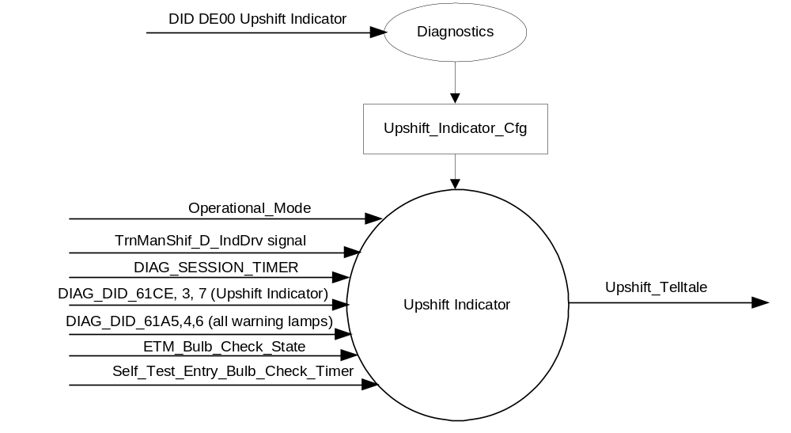Upshift Indication

Inputs

      - INTERNAL:
            - DIAG_SESSION_TIMER
            - Operational_Mode
            - DIAG_DID_61A5,4,6 (all warning lamps)
            - DIAG_DID_61CE, 3, 7 (Upshift Indicator)
            - ETM_Bulb_Check_State
            - Self_Test_Entry_Bulb_Check_Timer
      - MUX message on the CAN Bus

- TrnManShif_D_IndDrv Signal
Signal Name | Size  (bits) | Detail | Units | Res | Offset | State Encoded | Min. | Max.
TrnManShif_D_IndDrv | 3 |  |  | 1 | 0 |  | 0 (0x0) | 8 (0x7)
 |  | No_indication |  |  |  | 0x0
 |  | Upshift_Fuel_Economy _recommendation |  |  |  | 0x1
 |  | Upshift_Performance_  recommendation |  |  |  | 0x2
 |  | Upshift_warning (fuel cut imminent and reaching rev limit) |  |  |  | 0x3
 |  | Downshift_recommendation |  |  |  | 0x4
 |  | Undefined |  |  |  | 0x5
 |  | Undefined |  |  |  | 0x6
 |  | Undefined |  |  |  | 0x7

Outputs
Upshift_Telltale, which is used to control the state of the LED

Function/Performance

Operational Modes

Mode | Differentiating Vehicle Conditions
Sleep Mode | UpshiftTelltale OFF
Limited Mode | UpshiftTelltale OFF
Normal Mode | UpshiftTelltale ON/OFF
Crank Mode | UpshiftTelltale ON/OFF

Voltage Levels

Refer to the Cluster Features table located in the Operational Modes and Voltage Range Strategies Section in this SPSS

Human-Machine Interface

Visual


Indicator Graphics / Display Format

For actual symbol definition refer to database #H.900 of the 03-0685 ARL requirement

Indicator Color Coordinates

Green - Reference SDS IL-0017

Indicator Characteristics

LED - Upshift Telltale

Audio

None.

System Accuracy

The Upshift_Telltale shall change the state of the Telltale within 100msec of a state change as indicated in the state matrix reference 1.3.5.1 Subsystem Algorithm Flowchart/ State Diagram

Operation: Performance and Functional

Subsystem Algorithm Flowchart / State Diagram

- State Matrix for Upshift Telltale
Operational_Mode | Upshift_  Indicator_Cfg |  | ETM Bulb_ Check_State |  | DIAG_SESSION_TIMER |  | Self_Test_ Entry_Bulb_ Check_Timer |  | DIAG_DID_61CE, 3, 7 (Upshift Indicator) |  | DIAG_DID_61A5, 4,6  (all warning lamps) |  | TrnManShif_D  _IndDrv Signal |  | Upshift_Telltale
Normal or Crank |  | Enabled |  | X |  | Not Active |  | X |  | X |  | X |  | Upshift_Fuel  _Economy _recommendation (0x1) |  | ON
 |  |  |  | ON (0x1) |  | Not Active |  | X |  | X |  | X |  | X |  | ON
Normal |  |  |  | OFF (0x0) |  | Not Active |  | X |  | X |  | X |  | Missing as per 1.4.1 |  | OFF
 |  |  |  | X |  | Active |  | Not Active |  | Not Received |  | Not Received |  | Upshift_Fuel  _Economy _recommendation (0x1) |  | ON
 |  |  |  | ON (0x1) |  | Active |  | Not Active |  | Not Received |  | Not Received |  | X |  | ON
 |  |  |  | X |  | Active |  | X |  | ON (0x1) |  | X |  | X |  | ON
 |  |  |  | X |  | Active |  | X |  | X |  | ON (0x1) |  | X |  | ON
 |  |  |  | X |  | Active |  | Active |  | X |  | X |  | X |  | ON
All Other Cases |  |  |  |  |  |  |  |  |  |  |  |  |  |  |  | OFF
X=Don’t Care
Not Received = The state when a DIAG_SESSION_TIMER is active and the DID has not been received

Operation Description (supports algorithm flowchart /state diagram)

- Upshift_Telltale shall default to OFF when transitioning from Sleep or Limited to Crank or Normal until commanded by the TrnManShif_D_IndDrv Signal.

Function Safety Classification (EMC)

B

Memory Storage

Parameter Name | Description | Value at  Battery Connect | Value at  Module Wake-up
Upshift_Telltale | Used to control the state of the LED | OFF (0x0) | OFF (0x0)
Upshift_Indicator_Cfg | Encoded indicator of feature presence controlled via CAN at EOL at VO plant. | Use Stored Value | Use Stored Value
TrnManShif_D_IndDrv Signal | CAN Signal sent from the PCM | No_Indication (0x0) | Do Not Init
DIAG_DID_61CE Byte 3 Bit 7 (Upshift Indicator) | Warning Lamp “B” Status, byte 3, bit 7 (Upshift Indicator) | 0 (0x0) | 0 (0x0)
DIAG_DID_61A5,4,6 (all warning lamps) | Warning Lamp status 2, byte 4, bit 6 (all warning lamps) | 0 (0x0) | 0 (0x0)
ETM_Bulb_Check_State | State indictator for warning bulb in ETM | OFF (0x0) | OFF (0x0)
Operational_Mode | 4 state indicator for cluster operational mode | Limited | Limited, Normal or Crank

Parameter Name | Description | Value at  Battery Connect | Value at  Module Wake-up
DIAG_SESSION_TIMER | Timer used to time-out a diagnostic session | Not Active | Not Active
Self_Test_Entry_Bulb_Check_ Timer | Timer used in diagnostic session to do a self check of telltales | Not Active | Not Active

Prove Out

No

Reconfigurable Telltale

No

Message Center Msg

None

Error Handling

Missing Message Strategy

The signals will be declared missing as per the Diagnostics section of this SPSS.

DTCs states and history will be determined as per the Diagnostics section of this SPSS.

If the Upshift_Indicator_Cfg is set to Disabled, the cluster shall never log a missing message DTC due to this feature.

Diagnostics

Self Test

Bulb illuminated during self test as per Self_Entry_Bulb_Check_Timer

Engineering Test Mode

Reference section “Dealer / Engineering Test Mode (ETM)”.

Part II Performance

Supported Diagnostic PIDs (Service $22 and $2F)
Number | PID / CommonID Name | PID Type
61CE | Warning Lamp “B” Status, byte 3, bit 7 (Upshift Indicator) | Bit Mapped
61A5 | Warning Lamp status 2, byte 4, bit 6 (all warning lamps) | Bit Mapped

Supported Diagnostic Trouble Codes (DTCs)
DTC | Description
C10000 | Lost communication with ECM/PCM

DID DE00:
Block  Num | Block Description | Byte(s) | Bits | State: Description | "0" | "1" | Default | Comments/ Information
PACKETED BLOCKS
$00 | Option Content (B&A) | * | * | Upshift Indicator | Disabled | Enabled | 0 (Disabled)
 | *Byte and bit location to be identified in Part II Specification for this cluster

Reference Specification

IS-0001 WARNINGS/INDICATORS/DISPLAYS PROVEOUT
IS-0046 INSTRUMENTATION MATERIAL RESISTANCE TO CLEANING
IS-0052 OPERATING VOLTAGES - FUNCTIONAL/PERFORMANCE
IS-0069 FUNCTIONAL IMPORTANCE CLASS
IS-0324 WINDSHIELD & OTHER REFLECTIONS
IS-0327 WARNING INDICATOR EVALUATION
IS-0329 FLICKERING OF LAMPS
IS-0379 NORTH AMERICAN WARNINGS AND INDICATORS STRATEGY

IL-0017 TELLTALE AND INTERIOR ILLUMINATION COLOR
IL-0021 CRAFTSMANSHIP - DISPLAYS
IL-0023 CLARITY/LEGIBILITY/READABILITY
IL-0025 INTERIOR ILLUMINATION INTENSITY
IL -0027 VISUAL CONTRAST
IL -0043 OPERATIONAL ENVIRONMENT FUNCTIONALITY
IL -0045 COLOR
IL -0047 TELLTALE; INDICATOR AND DISPLAY LIGHT INTENSITY
IL -0048 ILLUMINATION ACCEPTABILITY

03-0661 PLACEMENT: CONTROL AND DISPLAY LOCATIONS
03-0662 PLACEMENT: LOGICAL GROUPING FUNCTION AND USAGE
03-0664 PLACEMENT: DOWN VISION TO COMPONENTS WITH HIGH VISUAL DEMAND
03-0665 PLACEMENT: EXPECTED LOCATIONS OF CONTROLS AND DISPLAYS VDS
03-0670 INTERIOR VISIBILITY
03-0671 INTERIOR VISIBILITY: REFLECTIONS FROM COMPONENTS & SURFACES
03-0672 INTERIOR VISIBILITY: REFLECTIONS IN DISPLAYS
03-0673 INTERIOR VISIBILITY: VISUAL OBSCURATIONS
03-0674 INTERIOR VISIBILITY: ILLUMINATION CONTROLS / DISPLAYS
03-0675 INTERIOR VISIBILITY: VEILING GLARE
03-0677 INTERIOR VISIBILITY: SUNLIGHT WASHOUT
03-0681 IDENTIFICATION: CHARACTER AND SYMBOL SIZE
03-0682 IDENTIFICATION: LEGIBILITY
03-0685 IDENTIFICATION: SYMBOLS, ABBREV FOR CONTROL
03-0721 LOGIC OF OPERATION: OPERATIONAL STEREOTYPES
03-0722 LOGIC OF OPERATION: INTERPRETATION
03-0723 LOGIC OF OPERATION: USE OF SYSTEMS WITH VISUAL DISPLAYS

Revision History

SPSS Module Revision History

Revision Level | Name | Change Description | Date
1.0 | V. Patel | Updated for Upshift telltale for CGEA1.3 based on FNA Upshift Telltale STSS ver 3.0. Changed STSS title to reflect CGEA1.3 implementation.  Section 1.1- Changed to CGEA based CAN input signal.  - Updated context diagram to include DID DE00 to read Transmission type as input instead of the old “TRANS_TYPE” CAN input. Updated to GGDS based diag DIDs and CGEA based CAN input signal.  Table 1.0 – Updated to CGEA based input signal  Section1.3.5.1 - Updated State Matrix Table to reflect CGEA based input and GGDS based diag inputs  Section 1.3.5.4 - Update Memory Storage table to reflect CGEA and GGDS based inputs.  Section 1.4.1 - Rewritten. Deleted references of specific missing message flags and timer.added new PID #  Updated DTC table to reflect GGDS based diagnostics.  Added table to denote DID DE00 | 6/30/2010
2.0 | JBlatchf | Upshift Indicator is becoming a regulatory requirement in EU countries. Intent of this change is to add Upshift Indicator specific configuration so the feature can be enabled where required in markets per regulation or to meet CAFÉ and disabled in markets where not required to prevent TGW. Color of indicator also changed from Yellow to Green to align with FoE.  1.1: Changed Config to enabled/disabled. Changed signal value to turn on telltale from 0x3 to 0x1. Direction per 6/6/2012 email from Jennifer Fazio of powertrain.  1.2.1: Changed Config  1.3.3.1.2: Changed indicator color to green.  Table 1.1: Changed Cfg  1.3.5.4: Modified Cfg  1.4.1: Changed Cfg | 6/22/12

